Stage 3 – "Two weeks from everywhere!"
COURSE DESIGNER: Ike Starnes (Blue Team Shooting Sports)
SCORING: Comstock 27 rounds.
TARGETS: 12 cardboard targets, 3 steel targets
SCORED HITS: 2 Best hits per carboard will be scored.

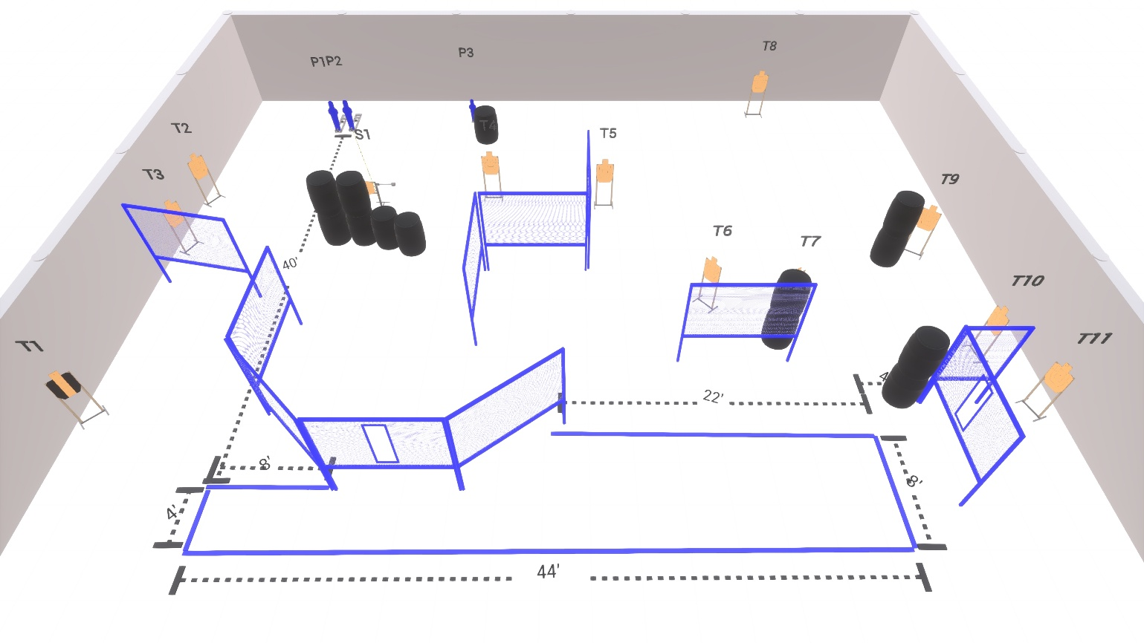

Written Stage Briefing:

Stage 3 – "Two weeks from everywhere!" - is a 27 round, 135 point, Comstock Course. There are 12 cardboard targets and 3 steel targets.

Starting with Both feet anywhere inside the shooting area.
Handgun is loaded and holstered, wrists below belt.
PCC is loaded held in both hands, stock on belt.

On the audible start signal, engage targets from within the shooting area.

USPSA / NROI Range Commands:
- Make Ready
- Are you ready?
- Standby
- If finished, unload and show clear
- If clear, hammer down and holster (Handgun)
If clear, hammer down and flag (PCC)
If clear, cylinder closed and holster (Revolver)
- Range is clear

Setup Notes:
10 Single Wall Stands
6 Double Wall Stands
8 Full Walls
2 Port Walls
1 Half Wall
11 Target stands / 22 target sticks
1 Swinger + cables + mover sticks
2 Large Activator Poppers
1 Small Popper
14+ Barrels



